STUDY HANDOUT | AI & ML PLAYGROUND
CONDITIONAL
PROBABILITY
Understanding Probability Through Real-World Examples

What Is Conditional Probability?
Conditional probability is the probability that an event A happens, given that another event B has already happened.
When we learn that B is true, we stop looking at every possible outcome. We only look at the outcomes where B is true. Then we ask: in what share of these outcomes does A also happen?
Think of it as zooming in. The new information makes our world smaller, and we calculate the proportion inside that smaller world.

The Formula and Notation
THE FORMULA
P(A | B) = P(A ∩ B) / P(B)
where P(B) > 0

P(A | B) | The probability of A, given that B has already happened.
P(A ∩ B) | The probability that both A and B happen.
P(B) | The probability that B happens. It must be greater than 0.

COUNTING VERSION  When all outcomes are equally likely:  Outcomes with both A and B  Outcomes with B |  | MULTIPLICATION RULE  Rearrange the formula to find the chance of both events:  P(A ∩ B) = P(B) × P(A | B)

Good to know: Conditional probability works whether or not A and B are independent. The only requirement is that P(B) > 0.

Visual Explanation: The Sample Space Shrinks
Imagine a class of 40 students. 20 know FastAPI only, 12 know machine learning (ML) only, and 8 know both.
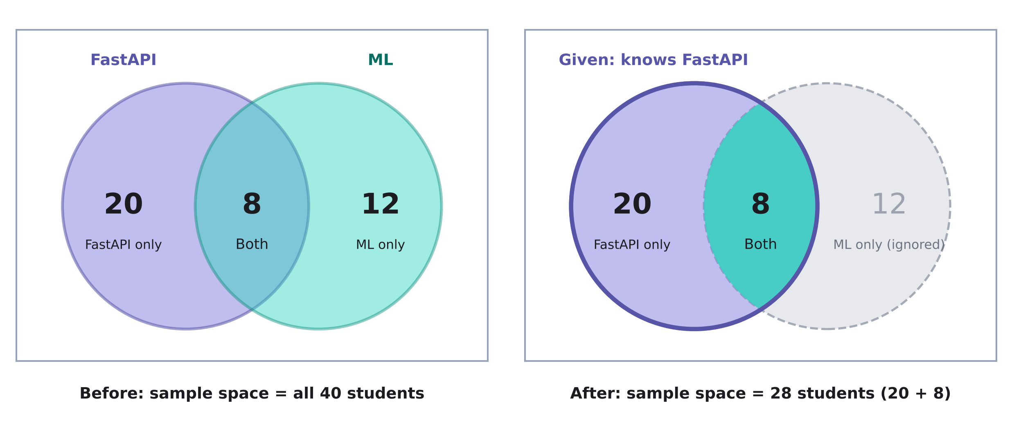
CONDITIONAL (GIVEN FASTAPI)  Only 28 students remain: 20 + 8. Of these, 8 know both.  P(Both | FastAPI) = 8/28 = 2/7 ≈ 28.57% |  | UNCONDITIONAL (NO CONDITION)  All 40 students count. Of these, 8 know both.  P(Both) = 8/40 = 20%

The key idea: once we know the student knows FastAPI, the 12 ML-only students are no longer possible. The denominator drops from 40 to 28, so the probability of knowing both rises from 20% to about 28.57%.

Step by step
- Start with the whole class: 40 students.
- Apply the condition. Keep only students who know FastAPI: 20 + 8 = 28 students.
- Inside this smaller group, count the students who know both: 8.
- Divide: 8 / 28 = 2/7 ≈ 28.57%. Compare this with 8 / 40 = 20% when we had no condition.

P(A | B) Is Not P(B | A)
It is tempting to think that swapping the two events gives the same answer. It does not. Using the same class of 40 students, we can ask two different questions about FastAPI and machine learning (ML) and get two very different probabilities.
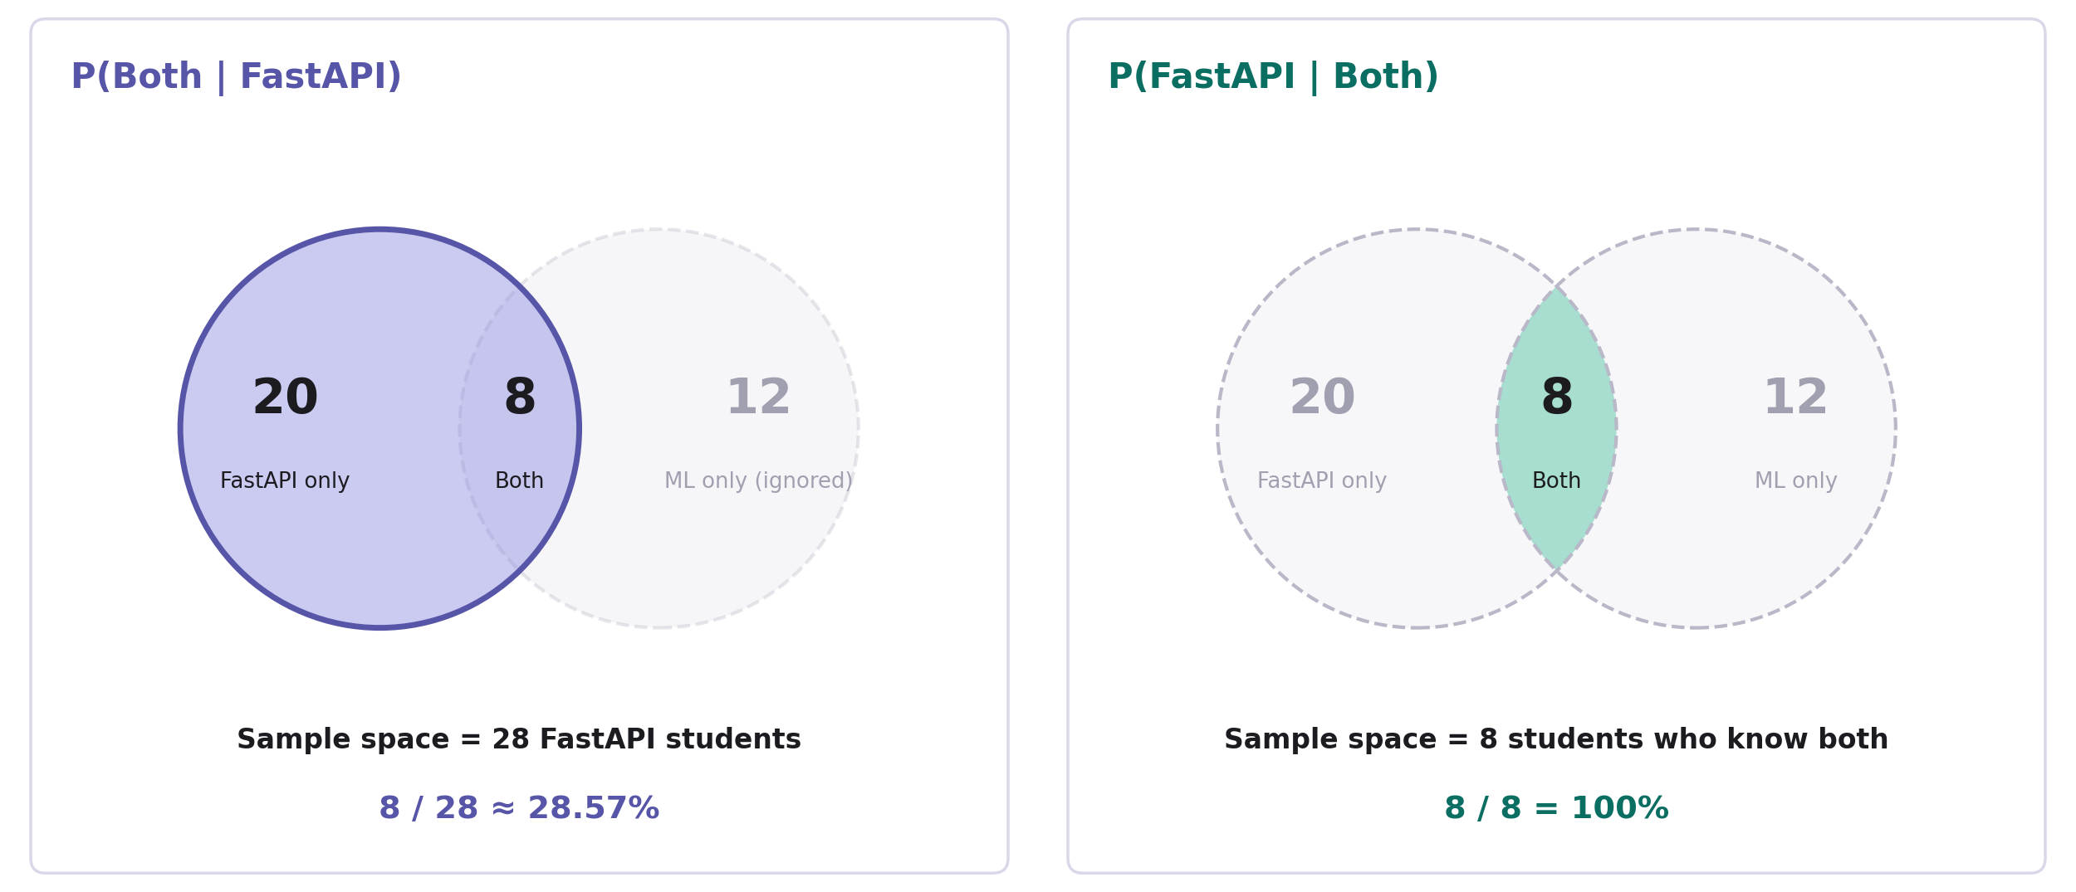
Same students, different condition, different sample space.
P(BOTH | FASTAPI)  Given that a student knows FastAPI, what is the chance they also know ML?  Sample space: the 28 FastAPI students. Of these, 8 know both.  P(Both | FastAPI) = 8/28 ≈ 28.57% |  | P(FASTAPI | BOTH)  Given that a student knows both FastAPI and ML, what is the chance they know FastAPI?  Sample space: the 8 students who know both. All 8 know FastAPI.  P(FastAPI | Both) = 8/8 = 100%

Why the answers differ: the condition after the vertical bar decides which students we look at. In P(Both | FastAPI), the bar says “FastAPI,” so the sample space is all 28 FastAPI students and only 8 of them know ML too. In P(FastAPI | Both), the bar says “Both,” so the sample space shrinks to just the 8 students who know both, and every one of them knows FastAPI. The numerator (8) is the same in both fractions, but the denominator changes from 28 to 8.
Remember: always read P(A | B) as “A, inside the world where B is true.” Swapping A and B changes the world, so it changes the answer.

Three Real-World Examples
EXAMPLE 1 MEDICAL TESTING
Positive Test Result
SCENARIO
A hospital studies 1,000 patients to see how a screening test performs.
GIVEN
- 100 patients have a particular disease.
- 90 of those 100 patients test positive.
- 180 patients test positive in total.
QUESTION
If a patient tests positive, what is the probability that the patient actually has the disease?
SOLUTION
P(Disease | Positive) = (disease and positive) / (all positive)
P(Disease | Positive) = 90 / 180 = 0.50 = 50%
We shrink the sample space to the 180 patients who tested positive. Of these, 90 really have the disease.
ANSWER 50%
WHY THIS IS USEFUL
Doctors and data scientists care about what a result means once it is known. Conditional probability answers that question directly.
Be careful: This is a simplified, hypothetical example. Real test results also depend on how accurate the test is and how common the disease is.

EXAMPLE 2 ONLINE SHOPPING
Coupons and Purchases
SCENARIO
An online store looks at 500 customers to understand how discount coupons relate to sales.
GIVEN
- 200 customers use a discount coupon.
- 150 customers use a coupon and complete their purchase.
- 250 customers complete a purchase in total.
QUESTION
Given that a customer used a discount coupon, what is the probability that they completed a purchase?
SOLUTION
P(Purchase | Coupon) = (coupon and purchase) / (all coupon users)
P(Purchase | Coupon) = 150 / 200 = 0.75 = 75%
Among the 200 customers who used a coupon, 150 completed their purchase.
ANSWER 75%
WHY THIS IS USEFUL
Businesses use this kind of analysis to understand customer behavior and to judge marketing campaigns.
Be careful: A high percentage alone does not prove that the coupon caused the purchase.

EXAMPLE 3 AI / ML
Student Performance
SCENARIO
A university studies 200 computer science students to see how Python practice relates to passing machine learning.
GIVEN
- 120 students practice Python regularly.
- 100 students practice Python regularly and pass machine learning.
- 140 students pass machine learning in total.
QUESTION
Given that a student practices Python regularly, what is the probability that they pass machine learning?
SOLUTION
P(Pass | Python) = (Python and pass) / (all Python students)
P(Pass | Python) = 100 / 120 = 0.8333 ≈ 83.33%
Only the 120 students who practice Python are in our sample space. Of these, 100 pass.
ANSWER About 83.33%
WHY THIS IS USEFUL
Data scientists use conditional probability to explore how features (like study habits) relate to outcomes (like passing a course).
Be careful: This shows an association only. It does not prove that Python practice causes students to pass.

Conditional Probability in Python
The same idea works in code. We build the class of 40 students, keep only those who know FastAPI, and then count how many of them also know machine learning.
● ● ● conditional.py
# 20 FastAPI only, 12 ML only, 8 both
students = ["D"] * 20 + ["M"] * 12 + ["B"] * 8

# Given: the student knows FastAPI
data = [s for s in students if s in ("D", "B")]

# Among those students, count the ones who know both
both = [s for s in data if s == "B"]

print(len(data), len(both)) # 28 8
print(round(len(both) / len(data), 4)) # 0.2857

How the code works
- D means FastAPI only, M means machine learning only, and B means both.
- The first list comprehension keeps only the students who know FastAPI (D or B). This is the condition. It gives 28 students.
- The second list comprehension picks out the students in that group who know both (B). It gives 8 students.
- Dividing 8 by 28 gives the conditional probability: 0.2857, or about 28.57%.

Practice Question
PRACTICE QUESTION
A university has 100 students. Of these, 60 know Python, and 30 know both Python and machine learning.
If a student is selected who knows Python, what is the probability that the student also knows machine learning?
A. 30%
B. 50%
C. 60%

Answer Key and Takeaway
ANSWER KEY
Correct answer: B. 50%
WORKING
P(ML | Python) = 30 / 60 = 0.50 = 50%
Why 60 and not 100? We are told the student knows Python. So we only look at the 60 Python students. The other 40 students are no longer possible, so they are not in the denominator.
Common traps: A (30%) divides by 100 and ignores the given information. C (60%) is just the share of students who know Python, not the share who also know ML.

KEY TAKEAWAY
Conditional probability means shrinking the sample space to what you already know, then asking how much of that smaller group also satisfies A.

